- \Operation\Basic settings\Reference offset values (page 1 of 2)
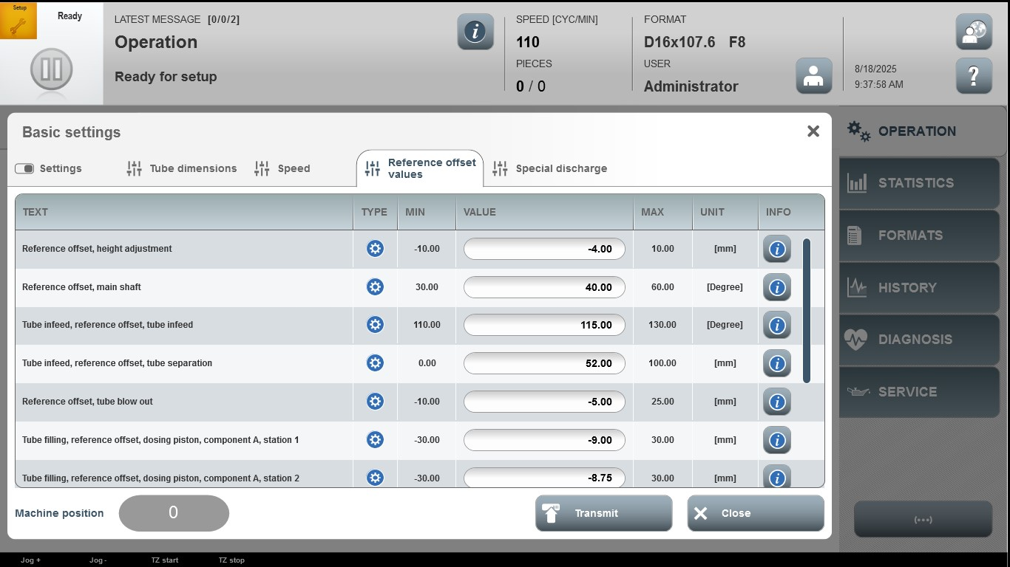

Acceptance criterion | Limits | Pass / Fail: Dev-No. | Date | Initials |  | Pass / Fail: Dev-No. | Date | Initials
Reference offset, height  adjustment | -10.00…10.00
Reference offset, main shaft | 30.00…60.00
Tube infeed, reference offset, tube infeed | 110.00…130.00
Tube infeed, reference offset, tube separation | 0.00…100.00
Reference offset tube blow out | -10.00…25.00
Tube filling, reference offset, dosing piston, component A, station 1 | -30.00…30.00
Tube filling, reference offset, dosing piston, component A, station 2 | -30.00…30.00

- \Operation\Basic settings\Reference offset values (page 2 of 2)
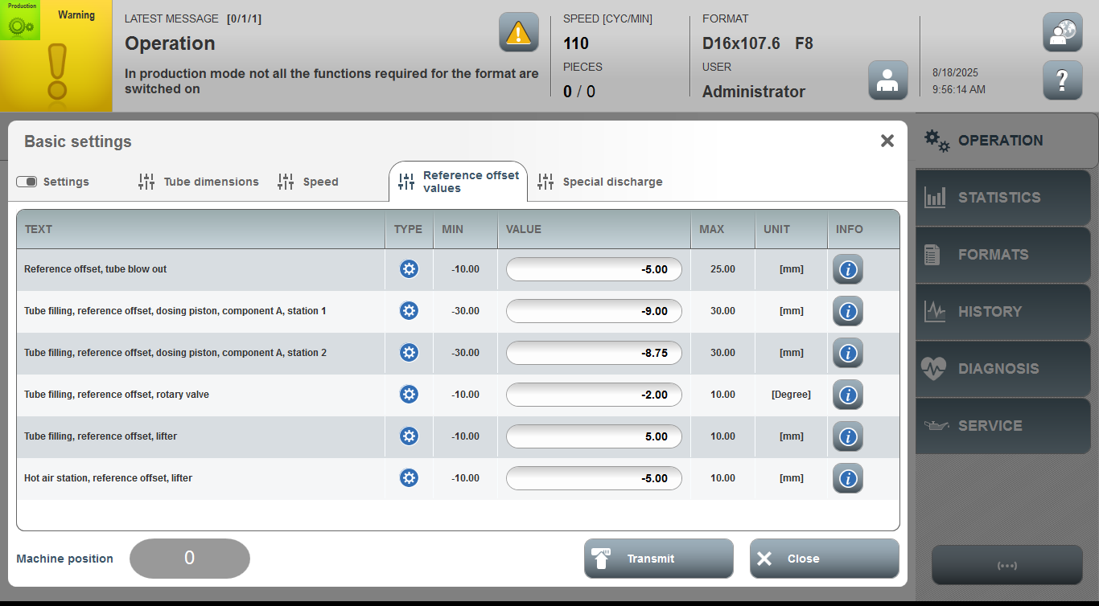

Acceptance criterion | Limits | Pass / Fail: Dev-No. | Date | Initials
Tube filling, reference offset, rotary valve | -10.00…10.00
Tube filling, reference offset, lifter | -10.00…10.00
Hot air station, reference offset, lifter | -10.00…10.00

